Hispanic Bilingual Gifted Screening Instrument www.teachbilingual.com
User’s Guide

September 2014

Inline Resources Ltd. Co.
Table of Contents
User’s Guide Overview 2
Roadmap 4
Classroom Area 5
Start 6
Classroom Report 8
Review Student Report 9
Modify Student 9
Delete Student 10
Administrator Area 11
Start 12
Classroom Report 12
Change Teacher 13
Delete Teacher 14
Implementation 15
Defining Terms 15
Usage 15

User’s Guide Overview
This Guide contains information used for demonstrating the best practices for using The Hispanic Bilingual Gifted Screening Instrument. It consists of information related to logon access, administrator area, classroom area, reports, tools, etc. essential in using the instrument.
Item | User’s Guide Information
Roadmap | The use of the tool takes 4 simple steps:  - STEP 1: Logon and Access the tool  - STEP 2: Use the Administrator Area  - STEP 3: Add teachers to the instrument  - STEP 4: Teacher logs on and accesses the classroom
Classroom Area | The evaluation of the tool begins in the Classroom Area. This location is automatically setup when the administrator adds the teacher to the instrument. The Classroom Area has 5 components:  - Start – The evaluation of the student begins by the teacher using the “Start” tool in the classroom. This allows the teacher to enter the students and immediately start the evaluation.  - Classroom Report – The data for every student evaluated are found in this report. The key features found are the student list, cluster totals, classroom average score, and gifted profile indicators.  - Review Student Report – The teacher can always review, modify, and complete any evaluation for individual students with this tool.  - Modify Student – A teacher can change the student’s name, age and other options here.  - Delete Student – A teacher can remove all records for a student with this option.
Administrator Area | The instrument is primarily managed by an administrator. This person is responsible for adding, deleting, and modifying the teacher accounts and reviewing the current results of each classroom. The Administrator Area has 4 components:  - Start – In order to use the tool the teachers need to be added to the instrument. This is where it takes place. The person’s name, ID, password, and grade level are the fields required. It is always best to issue unique passwords for all teachers. Once the teacher obtains the password, along with the school ID and password, the teacher will be able to log on.  - Classroom Report – The data for the classroom are found in this report. It gives the administrator full access to the current data of every classroom. The administrator can also instantly determine if an evaluated student is profiled as gifted.  - Modify Teacher – An administrator can change the teacher’s name, ID, password, and grade level here.  - Delete Teacher – A teacher can be removed from the instrument, along with all classroom data with this tool.
Implementation | HBGSI is used primarily in conjunction with other instruments for better identification of Hispanic bilingual students in grade PK-4. There are two instruments; one for PK and one for K-4. The research is based on a study by Texas A&M and Sam Houston State University. Please visit http://www.teachbilingual.com for more information about the instrument and about the authors.

Roadmap
The general steps required to use the Hispanic Bilingual Gifted Screening Instrument are found in this figure.
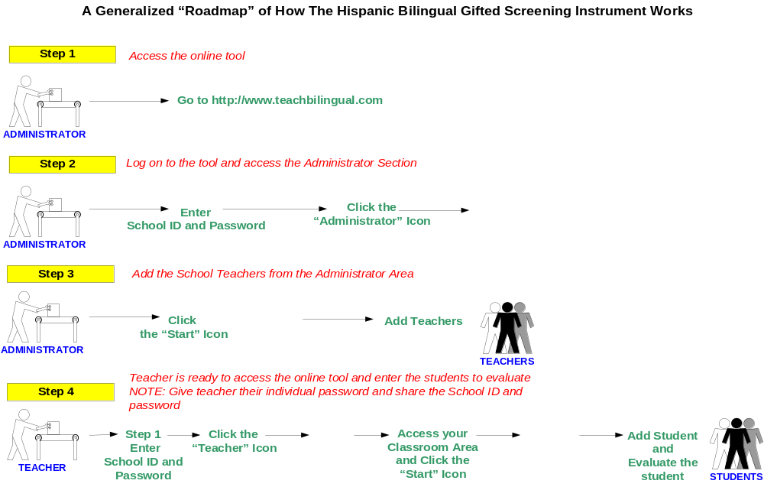

NOTE:
Once the teacher is added to the instrument they will need the global school ID and password in order to log on to the instrument. They will proceed by going to the Teacher Log On section and enter the unique password setup for them by the administrator.

Classroom Area
A teacher accesses the classroom area once the administrator of the tool adds them to the instrument, and assigns them an individual user ID and password.
Figure: Classroom Area
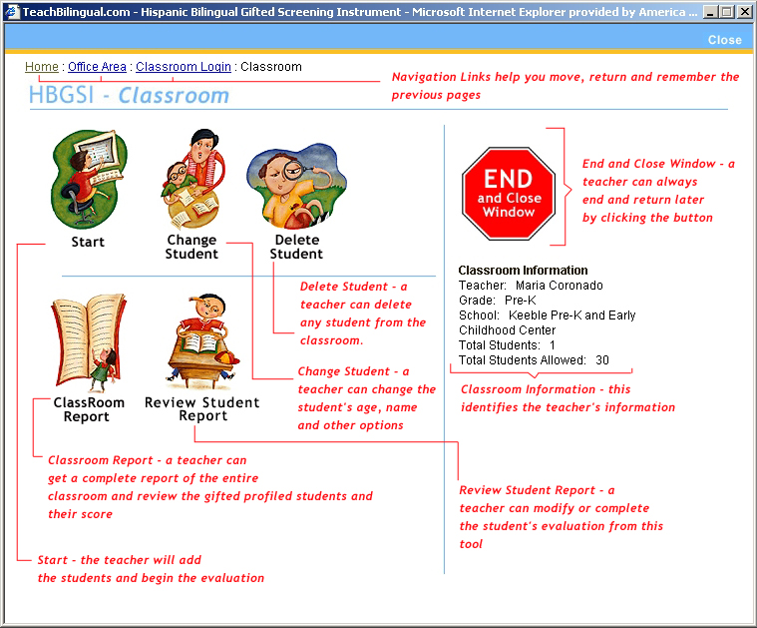

Start
The Start utility allows the teacher to begin the evaluation of the student:
- The teacher will add the student.

Figure: Start A
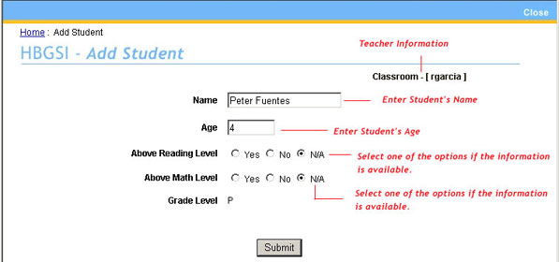

- The teacher will proceed with the evaluation of the student by answering the series of questions and scoring a mark for each question.

Figure: Start B
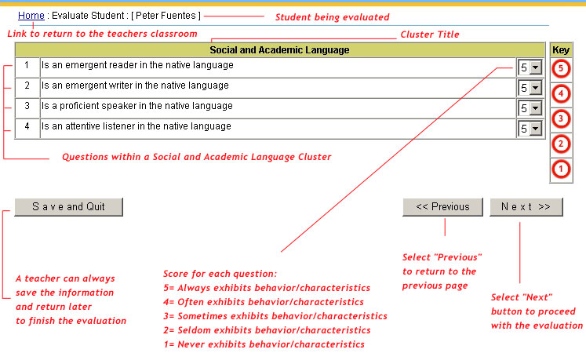

- Once completed, the teacher will get a Student Report which indicates the scores for each cluster of questions.

Figure: Start C
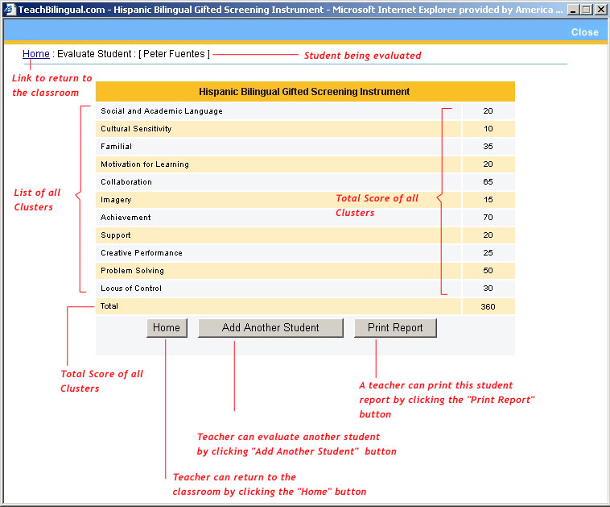

NOTE:
The teacher can proceed to evaluate another student, print report, and return to the classroom with the option buttons.

Classroom Report
The data for every students evaluated are found in this report tool. The items found here are the students list, cluster avg., score and gifted profile indicators.
Figure: Classroom Report
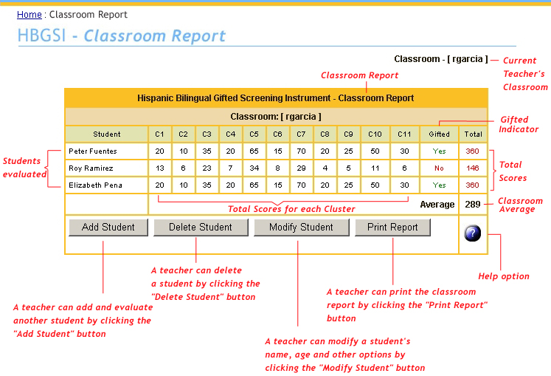

NOTE:
The teacher can add, delete, and modify a student, and print the report with the optional buttons.

Review Student Report
The teacher will be able to print the report, review, modify and complete any student’s evaluation marks with this tool.
Figure: Student Report
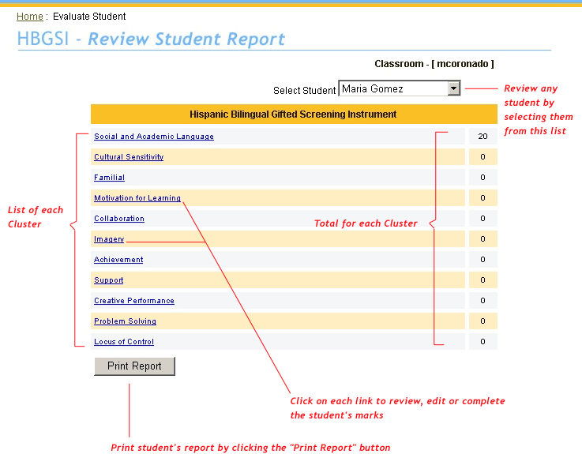

Modify Student
All students in the list can be modified by selecting the student and clicking the “Enter Student” button.
Figure: Modify Student
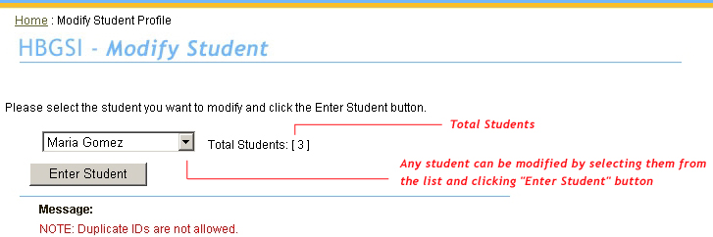

The teacher can modify the student’s name, grade, and other options with this tool by clicking the “Modify Student” button.
Figure: Modify Student Options
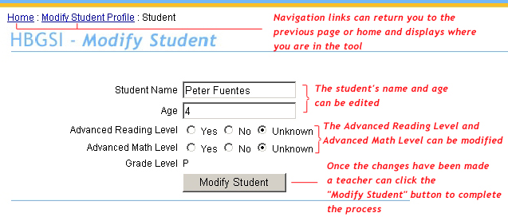

Delete Student
The teacher can remove a student from the classroom by selecting the student and clicking the “Delete Student” button. A warning message will be displayed for a confirmation.
Figure: Delete Student
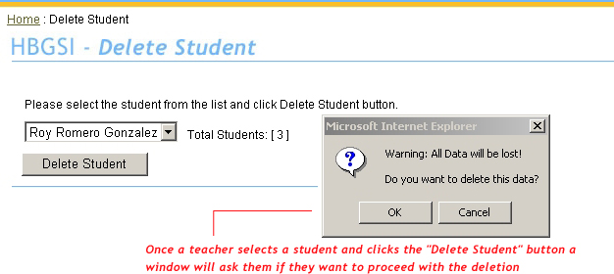

Administrator Area
The instrument is managed from one central location. This is the Administrator Area where the teachers’ access accounts are added, modified, and deleted. This area also includes a Classroom Area where the current data for every student in every classroom can be closely monitored.
Figure: Administrator Area
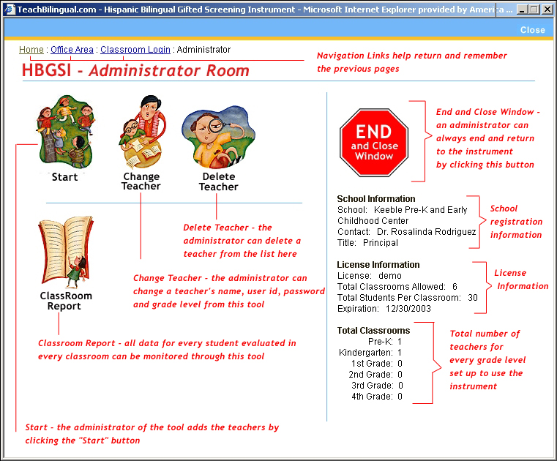

Start
A teacher is added to the instrument by using this tool from the administrator area.
Figure: Start – Add Teacher
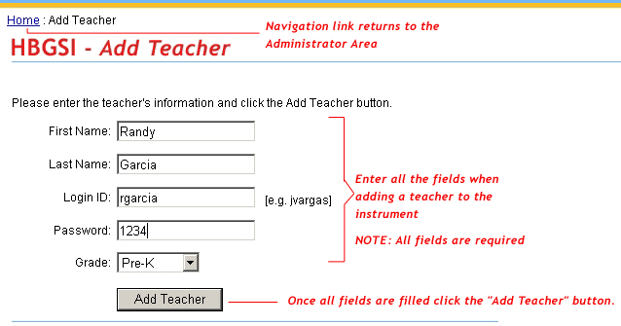

Classroom Report
The data for evaluated student in each classroom will be accessible through this report.
Figure: Start – Add Teacher
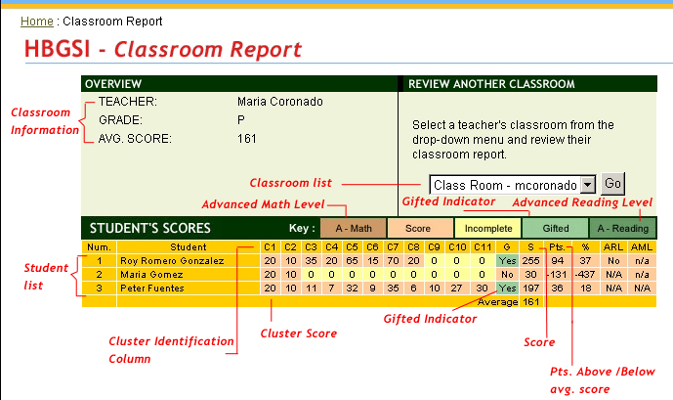

Change Teacher
The teacher’s account can be modified by selecting them from the list.
Figure: Start – Add Teacher
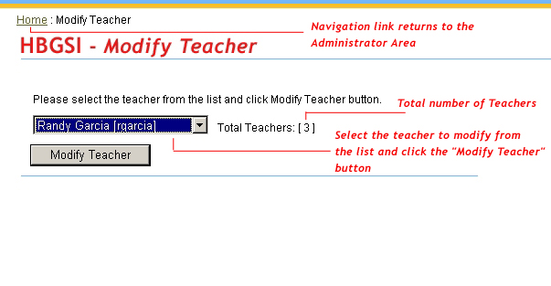
Once the changes have been made the “Modify Teacher” button is clicked to submit the modifications.
Figure: Start – Add Teacher
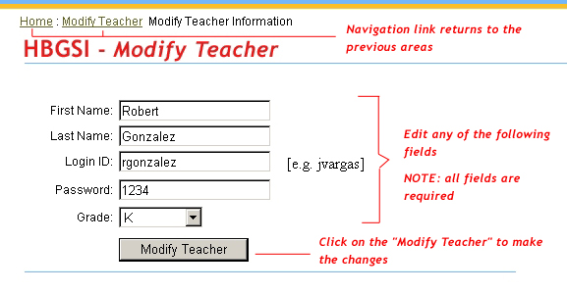

Delete Teacher
The teacher can be deleted along with all the classroom information by selecting them from the teacher list.
Figure: Delete Teacher
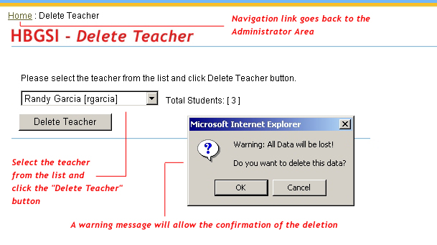

Implementation

Defining Terms
The HBGSI takes into account our definition and construct of the Hispanic bilingual child which is based on Joe Renzulli’s original definition of “above average intelligence, creativity, and task commitment.” However, as important as the general descriptors are, there are constructs that are critical to defining the Hispanic bilingual gifted child and which encircle the general definition of giftedness-- socio-linguistic-academic-cultural constructs.

Usage
Generally, in gifted education programs there are three phases in the identification process:

- Nomination or referral
- Assessment
- Recommendation for placement.

The HBGSI can be used in Phase 1 of the identification process as a referral instrument that would move the student to Phase 2—Assessment.
Additionally, the HBGSI can be used within a district’s matrix for Phase 3—Recommendation for placement.
Other potential instruments for use with Hispanic English language learning students who demonstrate gifted potential within a district matrix follow:

Tejas Lee

Aprenda

La Prueba

Bateria Woodcock

SABE

Naglieri Nonverbal Abilities Test (NNAT)

Bilingual Verbal Abilities Tests (BVAT)

Hispanic Bilingual Gifted Screening Instrument

Ethnographic assessment procedures

Dynamic assessment procedures

Portfolio assessment

Test scores

Teacher observation

Behavioral checklists

Past school performance

Parent interview

Writing samples or other samples of creativity/achievement

Input from cultural group.

